Assignment_1

**To create a Git account and repository, you can follow these steps:**

**1. Sign up for a Git hosting service**: There are several Git hosting services available, but GitHub, GitLab, and Bitbucket are among the most popular. Visit the website of the service you prefer and look for a "Sign Up" or "Create Account" option.



**2. Provide necessary information:** You'll typically need to provide some basic information such as your email address, username, and a password to create your account.

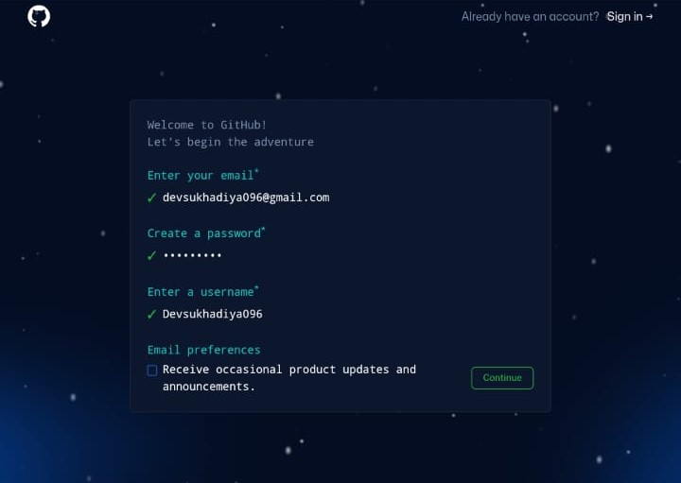

**3. Verify your email (if required:** Some services may require you to verify your email address before you can proceed. Check your email inbox for a verification message and follow the instructions provided.

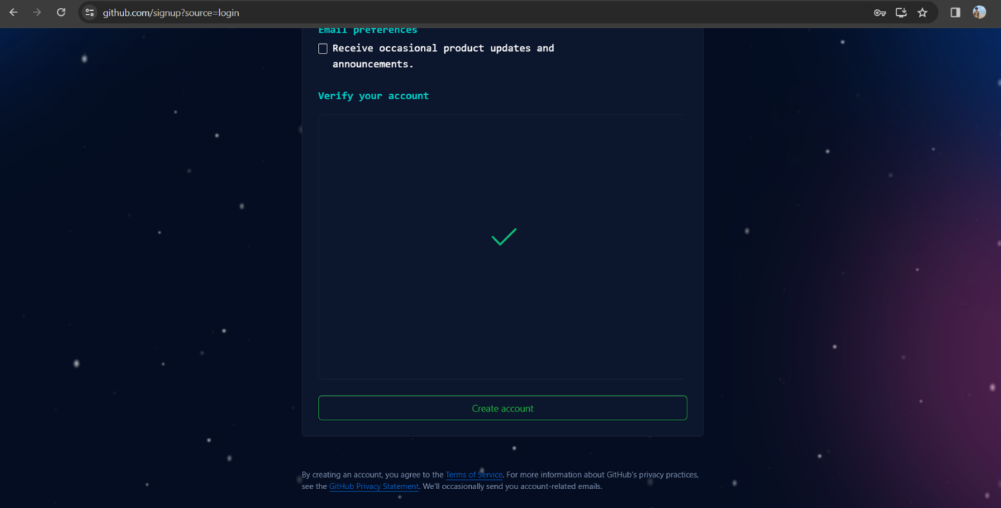

**4. Create a new repository:** Look for an option to create a new repository. This option is usually prominently displayed on the dashboard or in a dropdown menu. Click on it to start the repository creation process**.**

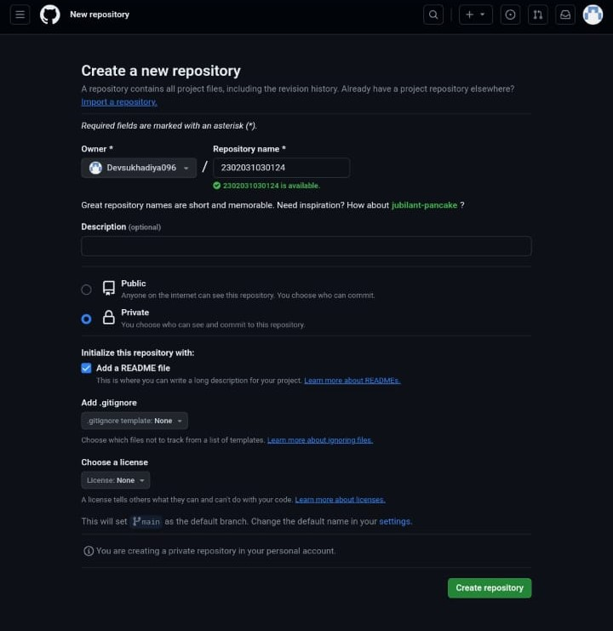

**5. Provide repository details:** You'll be asked to provide some details about your new repository, such as its name, description, and whether it should be public or private. Fill in this information according to your preferences.

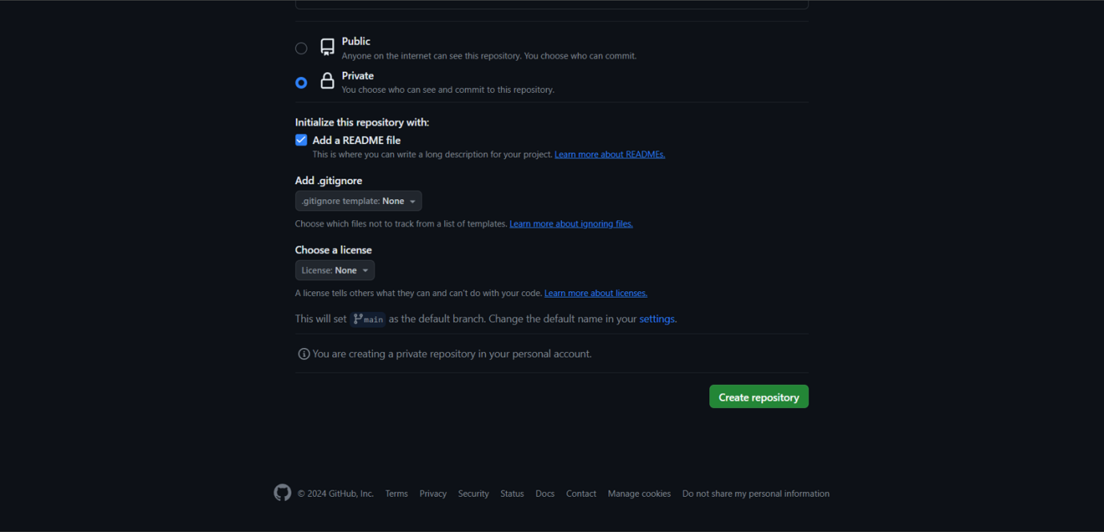

**6. Initialize with a README (optional:** Some services offer an option to initialize the repository with a README file. This file provides a brief description of the project and is commonly used to provide instructions or documentation. You can choose whether to initialize the repository with a README or not**.**

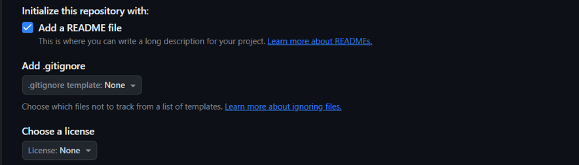

**7. Create the repository:** Once you've provided all the necessary information, click the button to create the repository. It may take a few moments for the repository to be created, depending on the Git hosting service and the current server load.

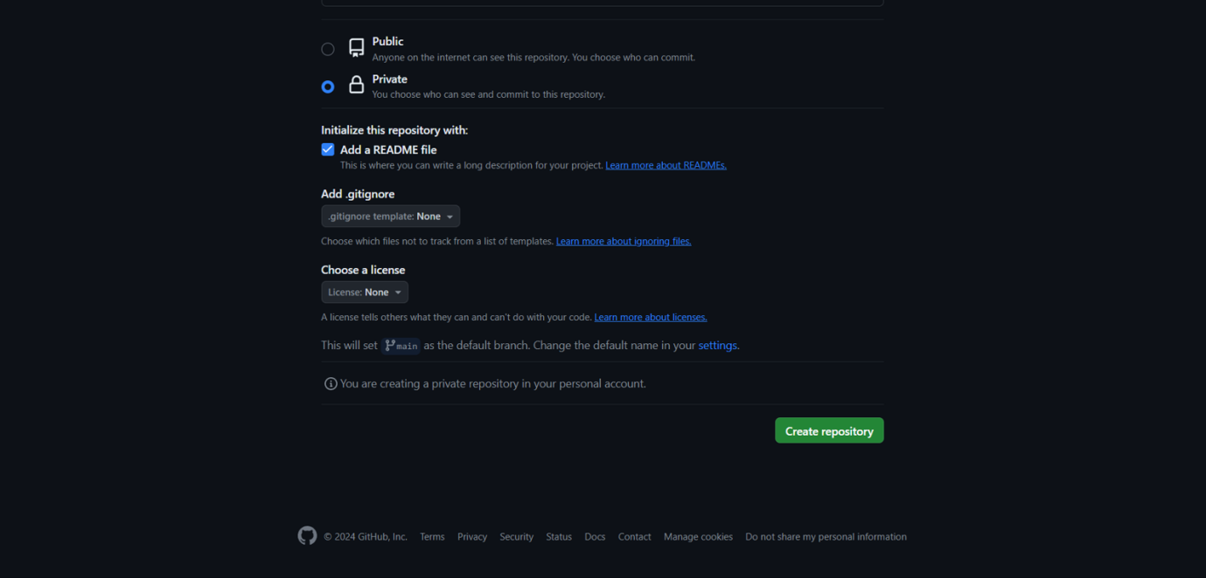

**8.** As per Task Assigned Create a GIT repository named as your enrolment number. Create 2

folder in your repository named as Assignment_1 and Assignment_2.

Note: - If you're creating a folder, give it a name. You can typically do this by typing the folder name followed by a forward slash ("/") at the end of the filename. For example, if you want to create a folder named "example", you would type "example/".

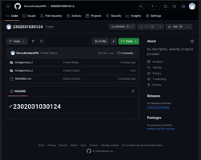

Once you've completed these steps, you'll have a Git account and a new repository ready to use. You can start adding files, making commits, and collaborating with others on your project.

Name: Dev Sukhadiya

Enrolment: 2302031030124

Branch: IT B-Tech

Class: IT4

Subject: WT

Semester: 4

Assignment: 1